Illustrative Learning Programme
An Integrated Approach

Grade 7

HIV and AIDS

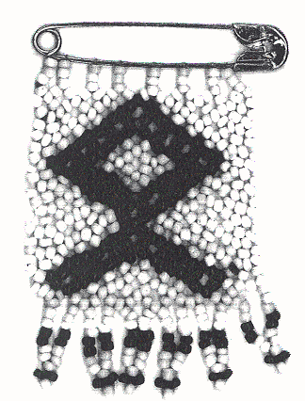

Learner’s material

UNIT ONE: Tuning in

By the end of this unit you will be able to:
- reflect on how you feel and behave when someone breaks a promise to you
- discuss reasons for not breaking a promise, and share your understanding of trust with others
- identify rules for creating a safe and supportive classroom atmosphere
- share some thoughts and feelings about relationships, sex and AIDS-related issues.

Activity 1.1 Tuning in to promises
Making a promise

A promise is an agreement to do or not to do something. Keeping a promise can be very difficult.

Have you ever broken a promise, or has someone broken their promise to you or betrayed your secret?

- Complete parts (i) and (ii) of this activity on your own. Read the questions and, in each case, choose the answer that best suits your feeling or behaviour.

- If a friend broke a promise to you, how would you feel?
- Sad
- Angry
- Hurt
- Understanding

- If you broke a promise to a friend and they told you how they feel, what would you most likely do?
- Say you’re sorry
- Make excuses
- Blame them
- Do something to make up

Remember that forgiving others for their mistakes is part of being a friend. It’s also important that you forgive yourself.

2. Form pairs and trace your partner’s hand on a piece of paper.
- Write both your name and your partner’s name in the palm of the traced hand.
- On each finger list a reason for not breaking a promise to your partner.
- Give the traced hand back to your partner and discuss your reasons for not breaking a promise.

Activity 1.2 Setting the scene

In this module you will be talking about relationships, feelings and sexual issues. You will also be finding out some facts about HIV infection and AIDS. Some of you may find it difficult to talk about some of the things related to AIDS. It is important that you treat each other in a respectful way and be considerate of each other's feelings. In this activity you will draw up a code of conduct to guide your behaviour while you discuss sensitive issues. Your teacher will guide the process.

Activity 1.3 Circle time is our time

This teacher-guided activity gives you a chance to express your feelings and opinions. Remember that circle time is your time, so you may say whatever comes to mind.

Activity 1.4 Raising issues

As your teacher guides this activity, you will create a graffiti wall on which you can express what you already know about AIDS, what you may have heard about AIDS, or what you believe about the disease. Below is an example of a classroom AIDS graffiti wall.

An example of an AIDS graffiti wall

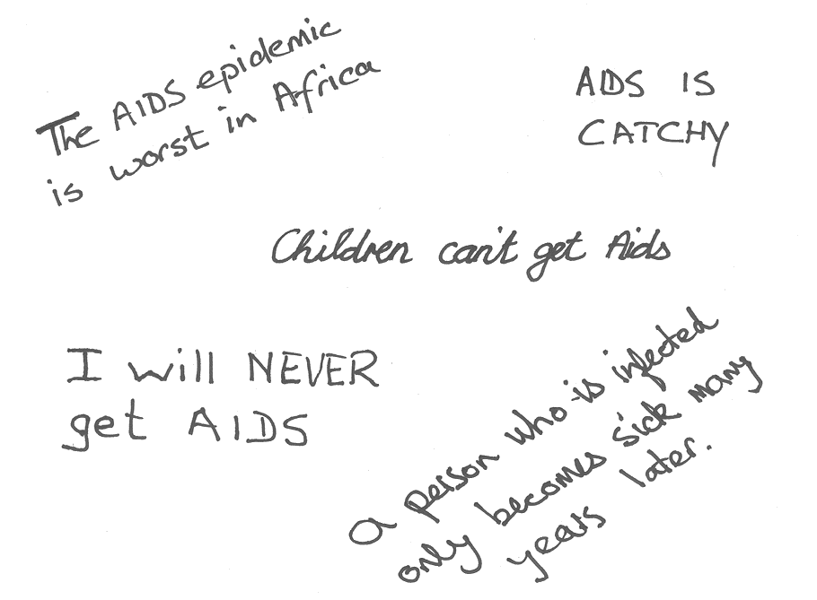
UNIT TWO: Finding out

By the end of this unit you will be able to:
- see how easily the HIV virus can be spread
- make informed choices about your own behaviour
- use skimming and scanning to find out some facts about HIV and AIDS
- change information from a text into a flow chart
- use new knowledge about HIV and AIDS to correct wrong ideas that you might have had.

Activity 2.1 Finding out: AIDS is no game

Your teacher will explain how this game is to be played.

Activity 2.2 Finding out some facts about HIV and AIDS: skimming and scanning

Below are several articles about HIV and AIDS. This activity will help you discover more about the disease, and will also teach you the important reading and research skills of SKIMMING and SCANNING. You will first practise SKIMMING.

- SKIMMING
- Read the information box below:

When we SKIM we read to get the general idea of the text so that we know what it is about without yet knowing any of the details. We do this by first looking for clues in those parts of the text which stand out. We concentrate on the headings, sub-headings, captions to pictures, and words in bold print.

- Now that you know what it means to skim a text, practise skimming each of the articles which follow (Articles 1 to 4) and make a note of the general idea by completing a table like the one shown here:

Title of the text | What is the text about?
- …………………
- …………………

Article 1
AIDS stands for:
Acquired (means to get from other people.)

Immune (means protected. The body is protected against many diseases by its immune system.)

Deficiency (means lack of. If a person has AIDS there is a lack of immunity against many diseases.)

Syndrome (which means a group of different signs and symptoms associated with a disease. When people have AIDS they have a syndrome of many different sicknesses or diseases.)

Article 2
AIDS: WHAT IS IT?

AIDS is a new and very serious disease, which can affect men, women and children.

AIDS is caused by a very tiny germ (called a virus). The virus can remain hidden inside the body for many years before the person becomes ill. This virus is called the HIV virus which stands for Human Immune deficiency Virus.

During the long period while the HIV virus is hiding, persons living with the virus look and feel completely healthy. Infected and healthy-looking people (men, women and children) can carry and pass on the HIV virus to others without knowing that they have it. People who have the virus are said to be HIV+ (HIV positive).

HIV+ people can pass the virus on to their partners during sexual intercourse. A healthy looking woman who is carrying the AIDS virus may pass it on to her unborn child when she becomes pregnant. Thus AIDS can affect any family members, including mothers, fathers and children.

Article 3

How HIV attacks the immune system

The HIV virus enters the bloodstream, either through the sex organs or straight into the blood, and then starts to attack and eventually destroy the body’s immune system. The immune system is how our body protects itself from disease. White blood cells are one of the key parts of the body’s immune system. These cells include B-cells and helper T-cells. The B-cells make antibodies that attack various organisms like viruses and germs that invade the body. The helper T-cells track down germs and destroy them. The HIV virus attacks the helper T-cells and multiplies in them, eventually killing them off. Without the T-cells, germs and viruses can’t be tracked down and destroyed and so the body gradually becomes sick.

The process during which the immune system is broken down by HIV takes many years. Eventually the body’s immune system is so weak that the body is unable to fight off infections. The HIV infected person then starts to get all kinds of illnesses, such as Tuberculosis (TB), Pneumonia, Thrush and many kinds of cancers. Some of these illnesses are quite common, and people with a strong immune system have a good chance of successfully fighting the infection if they are properly treated. However, people whose immune systems are weakened by the HIV virus cannot fight off these infections, which eventually kill them.

Article 4

Origin, cure and risk

Where did AIDS come from?

It is not known where in the world AIDS came from. There are many different theories, but none has been proven. People are now more concerned with reducing its spread than with worrying about where it originated.

Will there be a cure? Can AIDS be prevented?

- The AIDS virus is very difficult to work with, and so far scientists have not been able to find a cure.
- Some medical drugs are available that help to slow down the progress from HIV to AIDS, but they are very expensive, have side-effects, and do not cure the person.
- Researchers are trying to develop a vaccine that will prevent people becoming infected, but this is proving difficult as the virus changes quickly.
- It is hoped that a reliable vaccine will be available soon and that it will not be too expensive to produce.

What is high-risk behaviour?

High-risk behaviour is anything that people do that places them at risk of becoming infected. This behaviour includes having different partners, having sex with someone who is infected, and doing anything that lets infected blood enter your system.

High-risk sexual behaviour includes:
- having many sexual partners
- unprotected sex with any infected person, even your faithful partner.

Safer sex includes:
- a long-term, faithful relationship in which neither partner is infected with the HIV virus
- correct use of a condom.

People are more likely to practise safe sex if they are not under the influence of drugs and alcohol. This is because the use of drugs and alcohol can lead people to do things they would not normally do.

The only way to be 100% safe is not to have sex.

SCANNING

You are now going to practise SCANNING the same four articles. But first read the information box below:

When we SCAN we are reading because we need to find answers to particular questions. We can only scan when we know what we are looking for. We scan by allowing our eyes to search the text for the information we need. We do this by moving our eyes quite quickly over the text, as we would do with our hands if we had dropped something on the floor in a dark place.

- Below are four questions about HIV and AIDS. Read each question and first decide from your skimming of the articles where you are most likely to find the answer. Then SCAN that article to find the answer and write it down.

- Where does the HIV virus live in the human body?
- If we can be vaccinated against measles and polio, why is it difficult for scientists to find a vaccine that will stop people from becoming infected with the HIV virus?
- What sort of sicknesses might someone with a weak immune system get?
- What is the difference between HIV and AIDS?

Activity 2.3 Finding out about the impact of HIV and AIDS on an economy, a

family and an individual: using a flow chart

One way of learning something new is to read information from various sources. A flow chart helps you to make meaning at a glance. In this activity you will learn how to process information by converting information from a text into a flow chart.

- Read the following article and then complete the sequence of the main events below, using the bracketed words as clues:

- The man becomes ill
- …… (wife… so farm…)
- Poor food crops and less money
- …… (treatment)
- Savings spent and livestock given as payment
- …… (man – burial and mourning practices)
- …… (time and money – so smaller area.)
- …… (farm conditions)
- …… (children)
- Crops less
- Little money for food
- …… (family’s health)
- Food prices rise
- …… (hunger)

Article 5
The effect of AIDS in rural areas in Zimbabwe
Many farmers in rural Zimbabwe grow food for the family to eat and cash crops to sell. These crops provide people who are not farmers with food and other things that they need, like cotton. The sale of the crops gives the farmer’s family money to buy the food that they cannot produce themselves, and money for tools and other supplies for the farm. Most farms are worked by the adults, with the children helping after school. Labour is hired at busy times. If the farmer or his wife becomes ill from AIDS, a cycle of hardship is started.

The cycle goes like this: the man is taken ill. While nursing him, his wife can’t weed the maize and cotton fields, trim the banana trees, dry the coffee, or harvest the rice. This means that her food crops are poor and that she gets less money from cash crops. Trips to town for medical treatment, hospital fees and medicines use up the family’s savings. Traditional healers are paid with livestock.

The man dies. Farm tools, sometimes cattle, are sold to pay burial expenses. Mourning practices forbid farming for several days. Precious time for farm work is lost.

In the next season the family does not have money to hire casual labour. They do the work themselves and have to plant a smaller area than usual. The children have to leave school to weed and harvest the crops. The family does not manage to grow as much food as it needs. With little home-grown food and without cash to buy fish or meat, the family’s diet and health suffer.

If the mother then becomes ill with AIDS, this cycle is repeated. If the family no longer has crops to sell, they become subsistence farmers. As this happens to more and more rural farmers, the overall production of crops in the country drops. This creates a shortage of food, so food prices rise and then many more people go hungry.

- Look at this flowchart to check your sequence of events and to see how the information has been presented:
Man falls ill.

Wife nurses him so farm is neglected.

Poor food crops so less money.

Hospital and traditional healer cost money

Savings spent and cattle given away

Man dies – funeral and mourning costs

No money for labour so smaller area planted.

Children leave school to weed.

Crops less.

Less money and food so family’s health suffers.

- Now make your own flow chart based on the information in Article 6. Follow these steps:
- Skim the article to get the main ideas. As you read, write down key facts.
- Scan the article to find the specific information about the 3 stages of HIV and
AIDS and the sequence in which they occur.
- Present the facts in a flow chart.
- Check your flow chart with a partner.

Article 6

The 3 stages of HIV and AIDS

❶HIV well  People look and feel well. They can live normal lives. They often don’t know that they have the virus. | 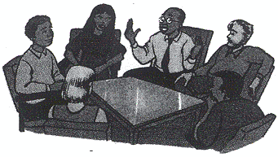
❷HIV ill  People start to get sick. They have symptoms like those of colds or flu. They sometimes need to visit a clinic or doctor. They do well with good treatment. | 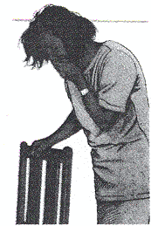
❸AIDS  People with AIDS get sick with serious illnesses. This stage of full-blown AIDS can take between 3 months and 15 years to happen, but usually takes from 6 to 8 years.  They need special care and treatment. | 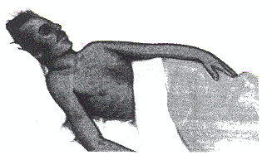

Activity 2.4 Finding out about the risks and myths: making and playing two games

There are many strange ideas about how people get AIDS. It is important for you to have the correct information so that you can be sure of your facts when you hear others talking.

- Read Article 7, How does HIV spread?

Article 7

How does HIV spread?

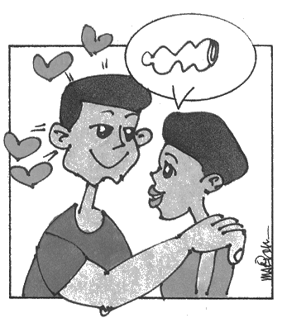 | Sex  The HIV virus is found in semen or vaginal fluids. You can become infected with HIV if you have sex without a condom with a person who is already infected with the HIV virus. In SA, the AIDS virus is most commonly spread when men and women have unprotected sex. It can also be transmitted by sexual contact between men and men and women and women.
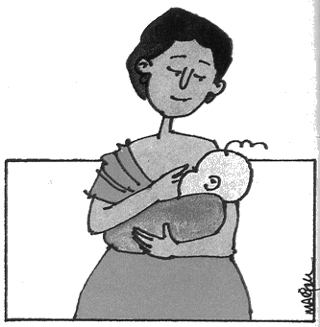 | Pregnancy and breast feeding  A pregnant mother with HIV and AIDS can give the virus to her baby while it is in the womb, during birth, or when she breast feeds
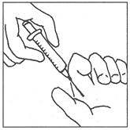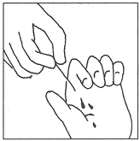 | Blood  The HIV virus can pass from one person to another if infected blood gets through the skin. Contact with infected blood can happen through sharing needles or syringes, sharing razors, or even sharing toothbrushes with an infected person.

- Take a few minutes to talk in a small group about what you know and what you have heard others say about how people get AIDS.

- Sometimes information can be processed into a game. Below are the instructions for making and playing two games to help you and your class to learn the correct facts about AIDS. Read through both games before you carry on.

- In your group choose one of these games and follow the instructions for making it. If you choose the Risk Game, try to add to the list of risk ideas provided below. If you choose to make the Myths and Realities Game, try to add to that list.

The Risk Game

- Cut out three cards with the following dimensions:

10 cm

30 cm

- Number the cards 1, 2 and 3

- Label the cards like this: Card 1 - HIGH RISK
Card 2 - SOME RISK
Card 3 - NO RISK

- Write out each of the words or phrases given below, as well as any you choose to add, on a separate piece of card. The writing should be large, so it would be helpful to draw two lines, 10 cm apart, onto the cards and to write between them.

Sharing needles
Fluids from reproductive organs
Playing sport
Prostitution
HIV+ mother to baby
Mosquito
Sex without a condom
Sharing toilet seats
Deep, wet kissing

Light kiss (peck)
Rape
Hugging
Sneezing
Sharing razor blades
Holding hands
Sex using a condom
Handling spilled blood

Each player is given a card. She/he sticks his/her card (using Prestik) under the headings HIGH RISK, SOME RISK or NO RISK. When the cards are in place, the group discusses whether the cards are in the correct positions and makes any changes that are necessary.

Your game will begin to look something like this:

HIGH RISK

SOME RISK

NO RISK

Sharing Needles
Sex using a condom
Mosquito

Prostitution
Light Kiss

The Myths and Realities Game
The game described above can be turned into a myths and realities game by using cards labeled MYTHS and REALITIES instead of the three RISK cards. The following statements can be written onto cards for the audience to play with:

Only the rich get AIDS
Only homosexuals get AIDS
I will never get AIDS
I don’t have AIDS and will never get it
AIDS is not curable
AIDS can kill
AIDS is only transmitted sexually
There are not always immediate
symptoms
Once you pass on the virus, you are
safe
An infected person always looks sick
People who are HIV+ cannot work
HIV+ learners are too sick to go to
school
A virus can be seen
Healthy people cannot get AIDS
AIDS can lead to other diseases
Sex with a virgin will cure AIDS
In SA, HIV+ learners are not allowed to
go to school.

- Go back to the graffiti wall that you wrote up in Activity 1.4. As a class, decide if there are any statements that you would like to change or add.
UNIT THREE: Counting Up

By the end of this unit you will be able to:
- work with HIV and AIDS statistics and use these statistics to gather information and make predictions
- represent statistics in different ways.

We need real information about who is HIV+ or living with AIDS and where these people are. The government, and organisations who work with HIV infected people, need this information so that they can make plans to help. The information also helps to educate people about safe behaviour and so prevent the virus from spreading even further.

Because HIV and AIDS is a growing problem, there are organisations such as the United Nations (UN) and the Department of Health that keep records of the number of people who are born HIV+, die from HIV and AIDS-related diseases, or test positive for HIV and AIDS. These numbers are grouped in different ways, and used to predict how many new cases of AIDS there are likely to be. We call the information about numbers and the way they are grouped statistics. Here is an example of an AIDS statistic:
In 1999, 200 000 children in SA under the age of 15 had lost their mother, father or both parents to AIDS.

Sometimes the use of statistics is the best way to get people’s attention and make them realize how serious a problem is. The government, community workers and other interested people use the statistics to help them plan what needs to be done to stop the disease from spreading.

Activity 3.1 Counting up young people in Gauteng who are HIV positive: demonstrating a statistic

For this activity you will need

a large, empty, clear plastic or glass container, preferably one with a wide neck, which can hold at least one litre
- some sand
- water
- a measuring jug.

Method
- Pour 600 ml of water into the container.
Imagine that the water represents all the people in Gauteng under 30 years of age. (This includes you!)
- Add 300 ml of sand to the water and let it settle to the bottom of the container. Imagine that the sand represents all the people in Gauteng under the age of 30 who are believed to have HIV or AIDS.
- About what fraction of the people in your age group are believed to have HIV or AIDS?
- As a class, talk about why we do not know exactly how many people in South Africa have HIV or AIDS. Think about the information you have already covered in this module to help you come to an answer.

Activity 3.2 A case study: reading to find statistics

- Read the following newspaper report about a family who have been affected by the AIDS crisis in South Africa.
- Note down from your first reading three pieces of information which are about numbers, for example, one girl and four boys.
- Rewrite each piece of information as a statement. For example, This family has one girl and four boys. This statement is about numbers and the ‘pattern’ they make. Statements like this are called statistics.

Sipho is 3 years old. Luisa, his sister, is 17. They have three brothers: Elias who is 20, Simon who is 14 and John, aged 9. They live in Soweto. Their parents have recently died and Luisa has taken over the role of mother in the family. They own a house and very little else.

Their father, Aaron, worked in an office. He was 45 when he died in September. Their mother was 43. Luisa tells their story.

They never really told us they were sick. It was only towards the end that they told us they had AIDS. They never told us they were dying. Some of the people in the community think we all have AIDS. Many people who used to greet us when our parents were alive now ignore us.

Sipho is the only child in the family who is HIV positive. He was asked to leave the local crèche soon after his parents died. A community worker helped the family by buying them food when their parents were alive.

A welfare organisation plans to adopt the family. The children will live in their parent’s house and the organisation will help to care for them with grants from the welfare.

Luisa and her four brothers became part of SA’s growing AIDS statistics in September 1999.

Activity 3.3 Some AIDS statistics: exploring big numbers

In 1998…
- 30 million people in the world were HIV positive
- 10 million children in the world got AIDS from their mothers
- 590 000 children were infected with AIDS
- 530 000 of these children were in Africa

The problem with HIV and AIDS statistics is that the numbers are so big. It is easy to read 30 million and not really understand how many that is.

- Take turns to read the numbers in the block aloud to your partner.
- Write the numbers 30 million and 10 million using numbers only and no words. How many zeros or noughts are there in each number?

We have to find ways of managing big numbers so that we can understand them easily. One way of showing big numbers is to demonstrate them physically as you did in Activity 3.1. Another useful way of understanding big numbers is to relate them to things that we know. Read at the information about Ellis Park Stadium in the block below. Then see if you can answer the questions using the information in the box.
This is a picture of Ellis Park Stadium. It holds 62 000 people.
How many times would all the children infected with HIV in Africa in 1998 fill Ellis Park Stadium? You may use a calculator to if you wish.

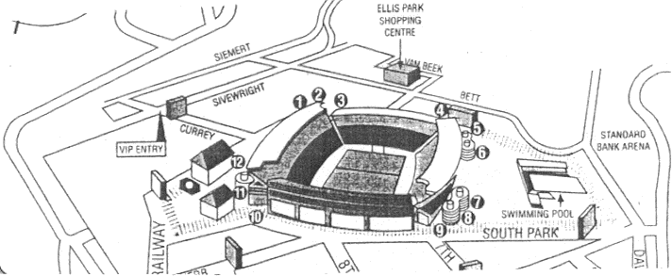

- Round off your answer to the nearest whole number.
- Compare the answer to that of your partner.
- Did you get the same answer?
- Did you do the calculation the same way?
- Tell your partner how you worked out the answer.
- Now write your answer as a statement.

- Find out the answers to these questions:
- How many learners are there in your class?
- How many learners are there in your school?
- How many spectators can fit into your nearest sports stadium? Use the information for Ellis Park for the activities that follow if you don’t have a stadium near you.

For each or the questions that follow,
- use a calculator, if you want to
- round your answer off to the nearest whole number
- write your answer as a number
- write your answer as a statement.

- How many times would all the people in the world who had HIV or AIDS in 1998 fill
- your school
- the nearest sports stadium?

- How many times would all the children in the world who got AIDS from their mothers (10 million children), fill
- your class
- your school
- the nearest sports stadium?

- How many times would all the children in the world who were infected with HIV and AIDS in 1998 fill
- your class
- your school?

Activity 3.4 More AIDS statistics: representing statistics as a diagram

There are about 48 million people in South Africa. One person in eight is infected with HIV or AIDS.

- Put a light pencil X (which you can erase afterwards) through the symbols in this illustrative diagram:

😐😐😐😐😐😐😐😐😐😐😐😐
😐😐😐😐😐😐😐😐😐😐😐😐
😐😐😐😐😐😐😐😐😐😐😐😐
😐😐😐😐😐😐😐😐😐😐😐😐

- Count the people in the your class. If one person out of eight in your class were to have HIV, how many people would be infected?

- How many people in South Africa are likely to have HIV or AIDS?
4.
- Read the information in the box below.

You know that there were 30 million people in the world with HIV or AIDS in 1998. The number 30 million is too big to illustrate in a diagram, so we need to use a scale to represent the number. We could use a symbol such as  to represent a group of people. In the example below,  represents 1 million people.




Number of people in the world who had HIV or AIDS in 1998

Scale
represents
1 000 000 people

- Now use the above example to illustrate the two statistics below. Do not forget to include the scale.
- Of all the people in the world who have HIV and AIDS, 9 out of every 10 people do not know that they are infected.
- 43 out of every 100 people with HIV and AIDS are women.

5. Discuss with your partner:
- what these statistics suggest about the growth of the world population
- what these statistics mean for people in your age group.

Activity 3.5 Children with HIV and AIDS: representing statistics as a pie-graph

- In pairs, read the information below and then discuss the questions which follow.

We can also show information about numbers as a pie-graph. A pie-graph shows statistics as part of a circle.
- About 3 million children and young people became infected with the HIV virus in 1998.
- 590 000 were under 15, and about 2,5 million were between the ages of 15 and 24, in 1998.

Here is a pie-graph showing these statistics. The whole pie represents the 3 million children and young people.
Under 15-year olds infected with HIV in 1998

- What does the larger part of the pie represent?
- What does the smaller slice of the pie represent?

- On your own, read the following statistics and then answer the questions which follow.
Record your answers in your Writing Book.

- 4 million children under 15 have been infected since the epidemic started.
- 9 out of every 10 of these children became infected from their mothers either at birth or while breast-feeding.
- Most of the children under 15 who were infected since the start of the epidemic now have AIDS or have died.

- Which of these statistics do you think the above pie-graph illustrates?
- How could the children in each slice of the pie have become infected?
- Compare your answers with a partner.

3. Working in pairs again, think back to the report about the family that you read at the beginning of this unit. Discuss how the information about the family can be linked to these statistics.

Activity 3.6 Counting the cost: a closer look at the case study

In pairs, discuss the questions allocated to you by your teacher, and be prepared to present this discussion to the rest of your group.

Set 1
Use all the information that you have from this unit to explain
- how the parents of the family in the report at the beginning of this unit could have become infected
- how long ago they are likely to have become infected
- how Sipho became infected
- why Sipho is the only child in the family to be infected
- which of the children could become infected in the near future.

Set 2
- What does it mean to take on the role of mother? Make a list of all the things Luisa will be expected to do in this role.
- How do you think being in the role of mother will affect her way of life?
- How do you think she feels about this change in her lifestyle?
- How do you think Elias feels? What extra responsibilities will he probably have now that his parents are dead?
- How do you think Sipho feels about not being able to go to crèche?

Set 3
- What effect do you think the father’s death had on the place where he worked?
- What effect did the mother’s death have on the community?
- Look back at the flow diagram on AIDS in Zimbabwe. How does the death of the parents affect people in a rural area such as the one in the Zimbabwe study?
- How is the experience of Luisa’s urban family the same as that of the rural family in Zimbabwe? In what ways are their experiences different?
- Look again at the story of Luisa and her family, and find three ways in which HIV and AIDS in this family will affect the economy of South Africa. Think of things that the State may have to provide for the family.

Activity 3.7 HIV and AIDS: applying statistics to your own life

- Read these statistics, discuss the questions below with a partner, and then each record your answers:

- Five out of every ten people with HIV or AIDS are aged 15 to 24
- 1,7 million young people in the southern parts of Africa became infected with HIV or AIDS in 1998. 530 000 of these were children under the age of 15
- By 2010 it is estimated that half the population of SA will have HIV or AIDS
- 1 700 people aged 15 to 35 become infected every day.

- How old will you be in 2010? Use the information in this unit to think and talk about how likely it is that you and you friends could get HIV or AIDS. Write a few sentences to explain your conclusion.
- Will knowing these statistics influence your behaviour? Why? Why not?
- What can you do to ensure that you do not become another AIDS statistic? Write down your ideas on a piece of paper or card. Keep this in a safe place where you can read it often as a reminder. Add new ideas to your list whenever you think of any.
Activity 3.8 Counting down: statistics change over time – a look at Uganda

1. Look at the information below and then discuss parts (a) and (b) with a partner.
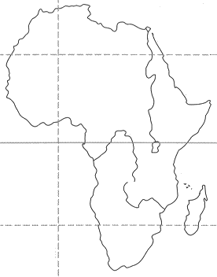
While South Africa’s statistics continue to get
worse each year, Uganda reports improvements
in their statistics.

Uganda

Uganda was one of the first countries to make a big effort to prevent the spread of the HIV virus. They did this by providing sex education and health programmes for the population.

The first bar graph shows the number of boys and girls in every 100 aged 15-19 years who were sexually active in 1989. The second graph shows the number of boys and girls out of every 100 in that age group who were sexually active in 1995.

- Compare the two sets of graphs. What can we deduce from them?
- Do you think Uganda’s AIDS education campaign has been successful? What makes you think this?

- Suggest some things your school could do to slow down the spread of AIDS. Write your suggestions on the slip of paper provided by your teacher.

UNIT FOUR: Taking Care

You have learned that the HIV virus can be spread through sexual contact and through blood products. So far in this module, you have been encouraged to consider safe sexual behaviour as a way of protecting yourself and others from infection. Now, in this unit, you will look at ways of protecting yourself and others from HIV infection which might occur through blood products. You will also review ways of taking care of people who are sick.

By the end of this unit you will be able to:
- protect yourself from HIV and AIDS, and know how to care for others who are ill or who have HIV and AIDS
- use your knowledge to give advice to people with problems
- show empathy and caring for those who are ill, especially people living with HIV and AIDS.

Activity 4.1 Discrimination against people with HIV and AIDS

- Read the case study on page 17 again and discuss the following questions in a small group:
- Why do you think Sipho has been excluded from the crèche? Do you think the crèche is right to have turned him away?
- What problems will this create for Luisa and Elias and Sipho?
- What does this tell you about the attitude of the school community towards HIV and AIDS?
- Why are people afraid to allow HIV and AIDS learners into school?
- What risk is Sipho to the community?
- Why do you think the parents only told the family that they had AIDS just before they died?
- Why won’t the community speak to the family now?
- How are the family being discriminated against?

Activity 4.2 Acting out

- Working in groups of five, each select a role of one of the children in the case study on page 17. You will be conducting a family meeting in which you will talk about how you feel and how the situation affects you, and you will try to find some ways of dealing with the situation.
What is a family meeting?
This is a discussion which allows all members of the family to be involved in decision-making. During the meeting they are able to discuss matters that affect them and other members of the family.

Guidelines for a family meeting
The meeting should only last for 30 minutes
Every one must have a turn
When it is your turn you must be calm
Say honestly how you feel and see things.
You must behave in a way to create trust in the group.
You may not interrupt another member while they are talking
You must respect others and listen to their point of view

- Your teacher will explain to you how to make a finger puppet. Once your puppets are ready you may conduct your family meeting. Try to remember some of the rules for a family meeting during your discussions.

You may have some people like Sipho in your school. You should have seen from your discussions that it is safe to play with them and for them to be at school as long as plans are made to deal with injuries. Because HIV and AIDS is an international problem, the World Health Organisation (WHO) has drawn up a list of suggested precautions. These are part of South Africa’s National Policy on HIV and AIDS. You will learn more about them in the next activity.

Activity 4.3 Preventing infection in accident and injury situations

- Read the universal precautions in the block below. What do you think the word universal means?

UNIVERSAL PRECAUTIONS WHEN DEALING WITH BLOOD

Universal precautions are the things we should do to prevent HIV infection when helping others in accident or injury situations. The precautions include ways of behaving when blood is spilt or when someone is wounded or cut. There is only a very small risk of becoming HIV infected when helping someone who has been injured as long as we are careful and follow the universal precautions:

- All cuts, wounds, blood and blood spills should be treated as if they could be infectious.

- Avoid skin, mouth and eye contact with blood.

- Always wear latex (rubber or plastic) gloves when cleaning wounds or blood spills. If there are no gloves available cover your hands with plastic bags and wash them with soap and water immediately after helping the injured person.

- Clean wounds with clean water and disinfectant. If possible, run the wound under a tap or pour water over it from a container.

- Always cover cuts, wounds, broken skin (lesions) or open sores with a bandage or a plaster.

- Clean blood spills immediately, preferably with household bleach.

- Place blood stained clothing and material in a plastic bag and throw it away or burn it later. If you have to wash clothing that is covered in blood, always wear gloves and use soapy water.
- A player who is injured on the sports field may not continue the game if there is bleeding unless the wound has been attended to, the bleeding has stopped and the wound is covered.

- Divide into groups of 6. Identify ways in which injuries that produce bleeding can occur at school.
- Work in pairs within the group. Choose an incident where there is an injury with blood. Role-play to the larger group what you would do to help the bleeder and keep yourself safe.
- As a group, draw up a list of rules to guide behaviour at your school, e.g. where to get gloves, where and how to wash the wound, where first aid equipment is kept, etc.
- Does your school have a policy based on the universal precautions that you are expected to follow? If it does, check your list of guidelines against the school’s policy. Can you improve the school’s list of instructions?
- Throughout this module you have learnt about how people become infected with HIV and AIDS and how to prevent this infection. Look back at the card that you made in Activity 3.7. Add some more ideas about how to keep yourself safe from HIV and AIDS.

Activity 4.4 What can I do to help?

According to statistics, more and more people are going to be seriously ill in the next ten years. In the case study of Luisa’s family, the parents were ill and then died. Sipho will also become seriously ill in the next few years.

- In small groups, think and talk about the following:

- Think about a time when you were sick. Who took care of you?
- What did that person do to take care of you?
- What were some of the things you wanted when you were feeling sick?
- What made you feel better?
- Think about the needs of someone who is ill.
- Prioritise five needs of someone who is ill.
- What must it have been like caring for sick parents?
- Who will look after Sipho and how will this be done?
- What would a sick person find comforting?
- What would a sick person find irritating?

Activity 4.5 How does it feel to be excluded?

People who are ill or have disabilities are often treated unfairly or rejected by others.

1. On your own, think back to a time when you remember being excluded. How did this make
you feel?

2. In your Writing Book draw up a sheet like the one shown here and complete it.

- I felt excluded when …

- I excluded someone when…

- I think she/he probably felt…

- Is there anything I can do to put this right now?

- Still working on your own, reread the case study. Try to imagine how Sipho felt when he was excluded from school.

4. Discuss some of the reasons for excluding others with the rest of your class.

Activity 4.6 Responding to others

Divide into small groups. Your teacher will give each group a Dear Abby letter to work on. Then follow the instructions below:

- Read the letter in your group and discuss the problem stated in the letter.
- As a group you will need to respond to the writer of the letter, advising the person on what to do.
- Choose a representative who will present your letter and response to the rest of the class.
- Listen to some of the other letters and responses. You may want to talk about how you would feel receiving this advice.
- Do you think the groups have given the person realistic advice? What would you like to add or change?

Dear Abby letters

Letter 1

Dear Abby

My teacher keeps telling us that people who smoke dagga and drink alcohol are more likely to become infected with the HIV virus. I just can’t see the connection and am not sure whether she really knows what she is talking about, or whether she is just trying to scare us. Please explain why she says this.

Joe

Letter 2

Dear Abby

When my aunt discovered that she was HIV-positive, the management at her place of work kept her job for her, even though she was absent quite often. She is now feeling much better and can be at work regularly once more. This means that she is again earning enough money to provide for her family and to afford treatment when she is sick. How can we support people like her and how can we encourage others to give their support?

Nomsa

Letter 3

Dear Abby

I was really upset at school today and don’t know what to do. This is my story: a few weeks ago a close friend of mine told me that the brother of Xoliswa, one of the girls in our class, has AIDS. He has apparently been sick for quite a long time, but the family have tried to keep it quiet. Now that the secret is out, several people in our class are saying that they don’t want to go near Xoliswa as they think she might also be infected and that they don’t want to take any chances. Today I found Xoliswa crying in the girls’ toilets, and when I asked her what the matter was, she said she had lost all her friends and couldn’t understand how people she had trusted and been close to could be so cruel. I feel really sorry for her and would like to support her, but I am unsure whether what the other people are saying is true. If I could convince them that they don’t need to stay away from Xoliswa I would try to, but I first need to be sure of my facts. Can you please help me?

Looking forward to hearing from you soon,

Joyce.

Letter 4

Dear Abby

I am thirteen years old and in Grade 7. I have two younger sisters, aged ten and seven, and a little brother who is three years old. My father died when I was in Grade 3, just before my little brother was born. I remember that he was often sick but would then seem to get better. But for quite some time before he died he was sick all the time, and was so thin and weak that he could not get out of bed. My mother nursed him at home and a neighbour came to our house while she was at work. I am now so scared because I notice that my mother is not well. She has lost a lot of weight and often has a bad cough and a fever. I have heard and read about AIDS, and I am afraid that perhaps that was the sickness my father had and that maybe now my mother also has it. Who will look after my mother? Who will bring home money for us to buy food and pay the rent? Who will look after us? How can I find out what is wrong with my mother? Please tell me what to do as I feel very frightened and alone.

Love

Jane

Letter 5

Dear Abby

I hope you can help me sort out my confusion! I am a member of our school’s First Aid team. Whenever there is a sport’s event at school or in the local community, we are expected to be there as First Aid helpers. I have just had an argument with my father who says I should stop being part of the team because I can get AIDS from touching other people who are bleeding. He also says that I can get AIDS by just touching the sweat on another person’s body. Surely he is talking nonsense? I really enjoy my First Aid work and don’t want to stop it, but I need more facts to convince my father that it is all right for me to carry on. As far as I know you can only get AIDS from having sex with someone, and anyway mostly only homosexuals get AIDS. I told him that I am too young to get AIDS, and that he should leave me to enjoy my teenage years without having to worry about such things. He also went on about becoming HIV-positive or something like that. I really didn’t understand what he was saying but didn’t want to ask him as I wanted him to think that I knew more than he did! Please tell me which of us has the correct facts.

Yours sincerely

Sipho

Letter 6

Dear Abby

I have an eighteen-year-old sister who is causing me a lot of worry. She often creeps out of our house at night after everyone has gone to sleep and only comes home in the early hours of the morning. I know about it because we sleep in the same room. I also know that she spends the nights with her boyfriend who lives two streets away. I have been told about the danger of AIDS infection at school and have tried to tell her too. I have told her that what she does is her own business but that she should make sure that she and her boyfriend never have sex without using a condom. She says that she is safe as he is the only boy she has ever slept with and he has told her that because she was a virgin when she met him, she can’t get AIDS and she will have cured him if he was already infected. Is this true? What advice can I give her so that she will be safe?

Miriam

UNIT FIVE: Making paper prayers

By the end of this activity you will be able to:
- think of your own messages of hope for people living with HIV and AIDS
- explore one or more printing techniques
- use art-making to express your special message
- display your paper prayers in an exciting way
- share thoughts and feelings about other people’s artworks or paper prayers.

By now you have learnt a lot about HIV and AIDS. In this last activity you will use art-making to create a paper prayer for people living with HIV and AIDS. What is a paper prayer? Paper prayers originate in Japan where people follow the very ancient custom of making painted strips of paper for people who are sick. These paper prayers express messages of hope and help people to deal with their illness. You are going to borrow this custom and make paper prayers for people who are living with HIV and AIDS.

Here are the steps to follow:

1. Thinking about your message

You will need:
- a piece of paper
- a pen or pencil.

Before you begin to make paper prayers, you need to think about your message or prayer. Start by gathering ideas and thinking about the following questions. Remember there are no right or wrong answers to these questions. Write down as many ideas as you can, and try to discover your own, unique, special message of hope. You do not have to use words. Add drawings of your thoughts and feelings if you prefer. Later on you will use some of these ideas when you make your artwork.

Who is your message for?

Is your message for someone, or a number of people you know? Is it for all children who have HIV and AIDS? Is it for people who are caring for people who have HIV and AIDS? Is it for people who have yet to discover that they are infected with the disease? Is your message for sick people who feel alone and frightened? It for people who have not heard of HIV or AIDS?
- Write down (or draw) a special person, or group of people to whom you would like to send your message.

What is your message of hope?

What would you like to tell this person or group of people? What feelings would you like to share with them? Is there a way that you can help them? Can you think of an imaginary gift that you could give this person or people?
- Write down (or draw) your special message of hope.

How can you express this message?

What pictures come to your mind when you think of your message? Are there particular patterns and colours? If you use familiar symbols such as a heart, think of a way of making them very special and unique. Remember that your message is personal and will look different to everybody else’s.
- Let your message flow onto the paper by drawing as many ideas as you can.

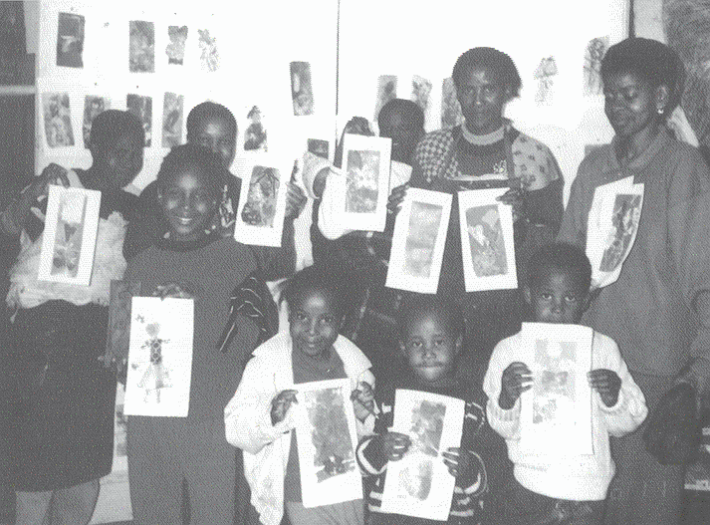

“Never doubt that a small group of committed people can change
the world. In fact, that is about all that ever has.
Just imagine the potential if we were all to join hands.”

Archbishop Desmond Tutu

2. Making a Paper Prayer

Like the Japanese, you will use a long, narrow piece of paper for your prayer (approximately 14 by 30 cm). Later, all of the prayers produced by your class will be displayed so that all your individual prayers become one combined message of hope.

There are many ways of creating a message on paper but you are going to explore a particular technique called printmaking. What is printmaking?

- Dip your finger into ink or paint and press it on paper. You have made a print! Anybody can make a print.
- There are many ways of making a print. Read through the ways suggested below, and then choose one, or more, of these ways to make your own printed paper prayer.

A. Object printing
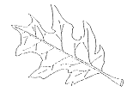
You will need:
- paper for experimenting
- paper for printing your prayers
- printing ink (you can also use thick paint)
- turpentine (if you are using oil-based ink)
- roller or sponge
- spoon
- newspaper
- smooth surface or slab on which to spread ink or paint
- flat, textured objects, for example: leaves, feathers, flowers, coins, scraps of lace,
fabric or woven mats
- cloth for wiping unwanted ink or paint.

a. Cover your table with newspaper so you do not damage the surface, and have pieces of paper ready to experiment on.
- Roll (or sponge) a layer of ink onto the surface of your object, taking care not to apply too much ink or paint. If you clog the surface of the object you will print a blob!
- Place a piece of paper on top of your object and rub on the paper, over the object, with your spoon.
- Carefully peel the paper off the object to find an imprint of the object on your page!
- Explore the textures of different objects. Experiment with the amount of ink you need to roll on your object to make a detailed, clear print.
- When you feel ready, print your paper prayer.
- When you have finished, put your print somewhere safe to dry.

B. Stamp printing
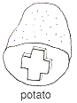

You will need:
- paper for experiments 
- paper for printing prayers
- printing ink (you can also use thick paint)
- turpentine (if you are using oil-based ink)
- roller or sponge
- newspaper
- sharp knife
- scissors
- smooth surface for ink or paint
- objects to stamp with, for example: potatoes, pieces of rubber, plastic, corks, styrofoam, cotton reels, etc.
- cloth for wiping unwanted ink or paint.

a. Cover your table with newspaper so you do not damage the surface, and have pieces of paper ready to experiment on.
- Cut and shape the surface of your object. If you want, add details by carving or scratching onto this surface. If you scratch letters into a surface, remember that they will look back-to-front when you print them. Try doing them back-to-front to start off with!
- Roll (or sponge) a layer of ink onto the smooth slab.

- Press the object into the ink on the slab and then stamp firmly onto paper.
- Experiment with different kinds of objects and different ways of repeating your designs.
- When you feel ready, print your paper prayer.
- When you have finished, put your print somewhere safe to dry.

C. Cardboard printing
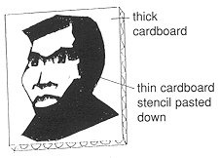

You will need:
- paper for printing prayers
- printing ink (you can also use thick paint)
- turpentine (if you are using oil-based ink)
- roller
- newspaper
- smooth surface for ink or paint
- different kinds of cardboard: thin, thick, textured (e.g. corrugated box cardboard)
- wood glue
- cloth for wiping unwanted ink or paint.

- Cover your table with newspaper so you do not damage the surface.
- Cut out a piece of firm cardboard which is the same size as your paper prayer.
- Cut out cardboard shapes to form a picture and glue them down on this cardboard.
- You can glue one layer of cardboard on top of another. Different kinds of shapes and textures will make your print more interesting.
- Leave to dry.
- Paint, or seal, with watered-down wood glue.
- When dry, ink over your design with a roller. You will find that the ink will not be able to reach all parts of your design.
- Carefully peel the paper off the cardboard. You will find an imprint of your design on your page!
- Put your print somewhere to dry.
- Re-ink your design if you want to make another print.

D. Stencil printing

You will need:
- paper for printing prayers
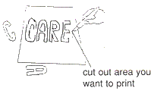
- printing ink (you can also use thick paint)
- turpentine (if you are using oil-based ink)
- roller or sponge
- newspaper
- smooth surface for ink or paint
- thin cardboard to make stencils
- scissors or cutting knife
- masking tape or Prestik (if available)
- pencil
- cloth for wiping unwanted ink or paint

- Cover your table with newspaper so you do not damage the surface.
- Cut out a piece of thin cardboard which is a bit bigger than the size of your paper prayer.
- Draw a picture onto this cardboard (you can also write a word). Keep the space around the edges empty.
- Cut out the parts you would like to be printed. Keep these lines and shapes simple so that they can be printed easily.
- Place your cardboard, or stencil, over your paper prayer.
- Hold carefully or secure with tape or Prestik. If you find that parts of cardboard are not connected to your stencil, stick them to your paper prayer with a small piece of Prestik.
- Roll an inked roller across the surface. Alternatively, sponge paint across the surface.
- Make sure you do not use too much ink or watery paint as it will creep underneath your stencil and spoil your design.
- Remove the stencil carefully and put your print somewhere to dry.
- Repeat if you would like to make another print.

3. Displaying Paper Prayers

How will you display your paper prayers? Your artwork will become more meaningful if lots of people can share and enjoy it. Here are some ideas to get you thinking about an exciting, meaningful way of displaying your paper prayers.

- The most obvious way to display artwork is to pin it on a wall in your classroom.
- Alternatively, you could suspend string from one side of your classroom to the other, and attach your prayers with pegs.
- Also consider displaying your work somewhere else. A public place, like a library or hall, would enable more people to see the paper prayers. Perhaps you would like to take your prayers to a hospital or clinic visited by HIV and AIDS patients?
- If you want to commemorate World AIDS Day you could display them on the 1st of December. Consider putting them outside, perhaps attached to the branches of a shrub or tree.

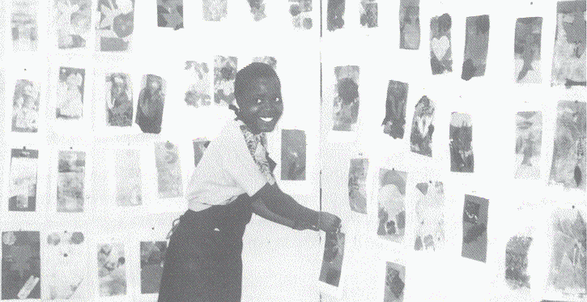

4. Talking about Paper Prayers

Finally, you will look carefully at your paper prayers and discuss them. When we talk about artwork it helps us learn and appreciate what we have done. Try to answer the following questions as you look at your display:

- Can you tell who some of the prayers are intended for? How can you tell?
- Can you work out what some of the messages mean? What are these messages? How
can you work this out?
- Do any of the prayers make you feel a particular emotion, e.g. peaceful, sad or happy? How
do they make you feel? Why does the prayer make you feel this way?
- Do you think any of the paper prayers are really unusual? Why?
- Can you find your three favourite paper prayers? Think why you like them.
- Think about what you have learnt in this activity.

When you have finished, share some of your answers and ideas with the rest of the class. Did anybody else share your favourite paper prayers?

FINDING HELP

Some of the issues discussed in this module may have made you feel uncomfortable or sad. This is to be expected and should move us to help in the fight against HIV and AIDS. We have learnt about ways of being compassionate, tolerant and helpful to others and also about ways of protecting ourselves. This is a list of resources that can help you get more information about HIV infection, sexual issues and AIDS:

AIDS Helpline 0800 012 322

AIDSLINK (011) 725 6202

Friends for Life (011) 487 1918

Department of Health (012) 312 0121
(for HIV and AIDS materials)

NAPWA National office (011) 403 8113

Planned Parenthood Association (011) 403 7740

Your local clinic

Your School District office

If you need to talk to someone about your feelings or concerns, you could call one of these numbers:

Life Line (011) 781 2337

Child Line 0800 055 555

AIDS Helpline 0800 012 322

You could also talk to someone close to you or to someone in the community, like a teacher, parent, minister or social worker.

