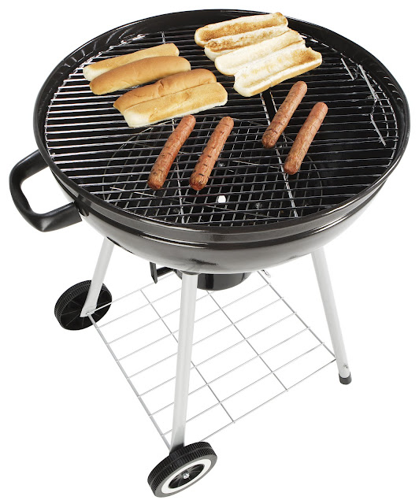
4th of July
Neighborhood Block Party

You’ve got burgers. We’ve got buns.
Come grill with your neighbors before it gets too hot, dog.

WHEN
Monday, July 4th
11:00 AM until 11:00 PM
Rain or shine

WHERE
Buzzy Pond Way
Parking on Blair Street

LIVE MUSIC by Bernard and the Black Books
FIREWORKS by Tim & Daisy's dad


SWIMMING @ BUZZY POND PARK

For more info, contact Ray: raymond.gilsig@gmail.com

