For Rent
1488 Villa Piña Way #201

2 bed 1.5 bath 900ft²
$1,550 per month
Spanish-style condo in great location
Won’t last! Available June 1

Contact Claire Vasquez @ (double-check cell #)

ABOUT VILLA PIÑA

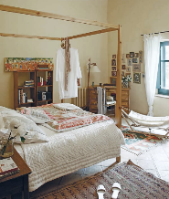

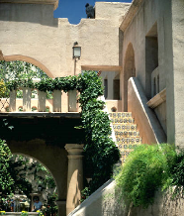
Beautiful grounds Dine-in kitchen Spacious bedrooms

Private but centrally located, historic Villa Piña is just moments from fine dining, shopping, and public transportation. Enjoy the best of both worlds at Villa Piña—the beauty of nature and the culture of a vibrant neighborhood.

For more information, visit us online:
www.villapinacondos.com

